Assignment Report

1. Assumptions regarding the problem context

The game may adding new hero in my design it will be more easy to manage the program, and it will conform to the open closed principle.

1. Application design with class diagram

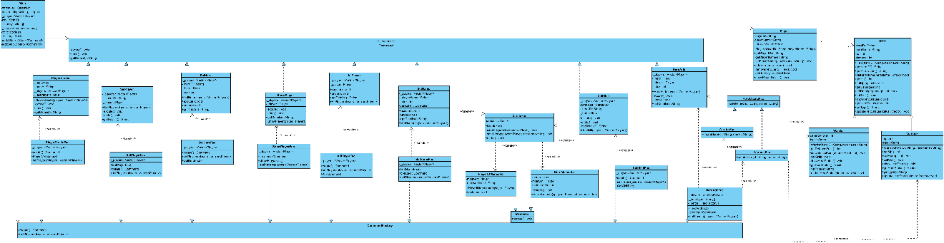

1. Discussion and explanation on each of the design patterns applied to the application

• **Command Pattern**: Used to encapsulate all commands related to player and hero management, allowing for flexible command execution and undo/redo functionality.

• **Factory/Abstract Factory Pattern**: Utilized to instantiate different types of heroes and command objects, ensuring that the system can easily accommodate new hero types in the future.

• **Memento Pattern**: Implemented to manage the state of the player during operations, enabling the undo and redo capabilities for actions like changing a player's name or calling a hero's skill.

1. Test Plan and Test Case

Test adding both types of heroes and ensure correct attributes are set.

Ensure that the display function correctly lists the player's details and their heroes.

1. Well documented Source Code

Follow a clear naming convention and maintain a logical structure within the codebase for enhance readability and maintainability.